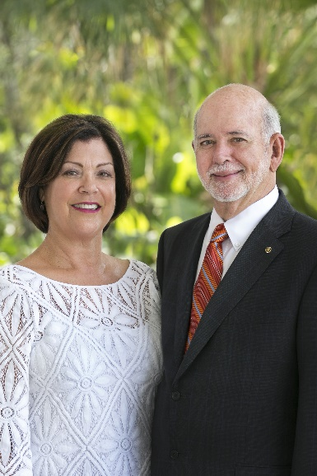
2018-19 年度
國際扶輪社長當選人 簡歷
拉辛Barry Rassin
Barry Rassin
President 2018-19
Rotary Club of East Nassau
New Providence, Bahamas
Barry Rassin earned an MBA in health and hospital administration from the University of Florida, and is the first fellow of the American College of Healthcare Executives in the Bahamas. He recently retired after 37 years as president of Doctors Hospital Health System and continues as an adviser. He is a lifetime member of the American Hospital Association and has served on several boards, including the Quality Council of the Bahamas, Health Education Council, and Employer’s Confederation.
A Rotarian since 1980, Rassin has served Rotary as director and is vice chair of The Rotary Foundation Board of Trustees. He was an RI training leader and the aide to 2015-16 RI President K.R. Ravindran.
Rassin received Rotary's highest honor, the Service Above Self Award, as well as other humanitarian awards for his work leading Rotary’s relief efforts in Haiti after the 2010 earthquake there. He and his wife, Esther, are Major Donors and Benefactors of The Rotary Foundation.
拉辛擁有佛羅里達大學保健及醫院管理碩士學位，也是美洲衛生保健主管協會的第一位巴哈馬會員。他擔任巴哈馬醫師醫院保健體系會長一職37 年之後，最近剛退休，目前擔任該會顧問。他是美洲醫院協會的終生會員，並擔任數個組織的理事，包括巴哈馬品質委員會、保健教育委員會以及雇主聯合會。
拉辛於1980 年成為社員至今，擔任過扶輪理事，目前是扶輪基金會保管委員會副主委。他曾是國際扶輪訓練領導人及2015-16 年度國際扶輪社長雷文壯的隨扈。
拉辛曾獲得扶輪最高榮譽──超我服務獎得獎人，也因在2010 年海地地震後領導扶輪救災工作而獲得其他數個人道獎項。他和夫人伊瑟Esther 都是扶輪基金會的鉅額基金捐獻人及捐助者。

