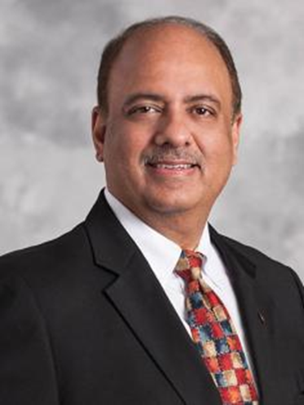
梅塔Shekhar Mehta

- 2021-22年度國際扶輪社長
- 加爾各答-馬哈內嘎(Calcutta-Mahanaga)扶輪社
- 印度西孟加拉邦
梅塔是一名會計師，是他創立的房地產開發公司「天際線集團」Skyline Group的董事長。他還是加拿大組織(印度)「寰宇視力手術」Operation Eyesight Universal (India) 的董事。
梅塔一直積極參與救災應變工作，並且是英國「急難庇護箱」ShelterBox的信託人。在2004年印度洋海嘯之後，他幫助為遭受災難影響的家庭搭建了近500間住家。
梅塔開創了一項計劃，在南亞進行了1500多次改變人生的心臟手術。他還打造了TEACH計劃，在全印度推廣識字，影響所及達數千所學校。
梅塔自1984年加入扶輪成為社員迄今，曾任國際扶輪的理事、多個委員會的委員或主委、地帶協調人、訓練領導人、扶輪基金會技術顧問幹部及地區總監。他還是(印度)扶輪基金會的主委。
梅塔曾榮獲扶輪超我服務獎、扶輪基金會特優服務獎及傑出服務獎。
他與夫人拉瑟Rashi是巨額捐獻者和遺贈會會員。
IV社長倡議
請舉辦一個扶輪服務日(Rotary Days of Service)：扶輪服務日是一個有意義的日子，辦理親手服務的活動，在這些場合扶輪的成員與社區聚集一起，共同改善他們的社區。
2021-22年度社長會議系列將會突顯扶輪社及扶輪地區在當地創先辦理及在全球支援實施的人道工作。請規劃出席一場社長會議(Presidential Conference)：
2021年10月4-5日---- 韓國慶州
2021年11月6-7日---- 義大利威尼斯
2021年11月26-27日---- 菲律賓馬尼拉
2022年2月12-13日---- 巴西伊瓜蘇
2022年2月25-27日---- 印度海德拉巴德
2022年3月4-5日---- 莫三比克馬普托

Shekhar Mehta
- President-elect 2020-21
- Rotary Club of Calcutta-Mahanagar
- West Bengal, India
Mehta, an accountant, is chair of the Skyline Group, a real estate development company he founded. He is also a director of Operation Eyesight Universal (India), a Canada-based organization.
Mehta has been actively involved in disaster response and is a trustee of ShelterBox, UK. After the 2004 Indian Ocean tsunami, he helped build nearly 500 homes for families affected by the disaster.
He pioneered a program that has performed more than 1,500 life-changing heart surgeries in South Asia. He is also the architect of the TEACH Program, which promotes literacy throughout India and has reached thousands of schools.
A Rotary member since 1984, Mehta has served Rotary as director, member or chair of several committees, zone coordinator, training leader, member of The Rotary Foundation Cadre of Technical Advisers, and district governor. He is also the chair of Rotary Foundation (India).
Mehta has received Rotary’s Service Above Self Award and The Rotary Foundation’s Citation for Meritorious Service and Distinguished Service Awards.
He and his wife, Rashi, are Major Donors and members of the Bequest Society.

IV. Presidential Initiatives
Host a Rotary Day of Service: a meaningful day of hands-on service activities where Rotary members and the community come together to improve their community.
Plan to attend a Presidential Conference. The 2021-22 presidential conference series will highlight the humanitarian work that Rotary clubs and districts pioneer locally and support globally.
- 4-5 October 2021 — Gyeongju, Korea
- 6-7 November 2021 — Venice, Italy
- 26-27 November 2021 — Manila, Philippines
- 12-13 February 2022 — Foz do Iguaçu, Brazil
- 25-27 February 2022 — Hyderabad, India
- 4-5 March 2022 — Maputo, Mozambique

